HOME AUTOMATION SYSTEM

Introduction:

Home automation is revolutionizing life in the home, bringing with it convenience, security, and efficiency as the defining feature of modern living. Imagine having the power to turn on lights, heat, and security in your home remotely from anywhere in the world with a tap of your smartphone or voice command. This project aims to develop a system that places total control of a smart home at the hands of the homeowner.

Our system will integrate a variety of smart devices, including lights, thermostats, door locks, smart fridges and security cameras, to create an integrated and adaptive living space. Users gain from tapping the potential of technology to be more comfortable and at ease of mind, knowing that they are secure and energy-efficient with their homes.

The primary goals of this project:

Offer an Easy-to-Use Interface: We aim to make sure that all the users, no matter how tech-savvy they are, will be able to navigate and manage their home devices with ease. A simple and intuitive interface will make managing your home easy and effective.

Install Automation Routines: With our system, customers will be able to customize routines according to their own needs. From scheduling lights to softly illuminate in the morning to pre-setting the thermostat to cool down during the night, such automated routines make users spend less time worrying about mundane stuff.

Enhance Safety: With real-time viewing and notification features, home owners have constant surveillance of their home online. From confirming the presence of an open front door to being aware of the presence of suspicious persons, this system aims to provide peace of mind to all home owners.

Functional Requirements:

- User Authentication
- Remote Control
- Automation Routines
- Remote Monitoring
- Voice Control Integration

Non-Functional Requirements:

- User-Friendly Interface
- Scalability
- Effectiveness
- Security
- Reliability
- Compatibility

Analysis:

The system should support multiple authentication methods (password, fingerprint, facial recognition, etc.).
Users should be able to register, log in, and update their profiles securely, while allowing different levels of user access (admin, guest, etc.).
The system should include authentication practices like two-factor authentication (2FA) for better security.
Users should be able to control lights, thermostats, door locks, security cameras, etc., remotely from any internet-connected location through a responsive, fast server.
The system must permit scheduling activities (e.g., setting the thermostat to adjust at particular times), or even complex routines, such as a composite of light, thermostat, and security camera activities. Most importantly, integrate different devices into routines (e.g., when motion of the security camera is detected, lock doors and send a notification to the user).
It should allow users to view live camera feeds, monitor the status of door locks, and view appliance status from a mobile device or web browser.
It should send push notifications for specific events, e.g., door unlocking attempts, motion detected, or unusual temperature.
Users should be able to use voice commands to manage devices (e.g., "Turn off the lights" or "Set the thermostat to 72°F") with minimal configuration needed from the user.
The mobile app and web interface need to be responsive and easy to use.
There need to be intuitive, usable controls for device management.
There needs to be multiple language support or UI customization.
There needs to be a tutorial or first-time user onboarding.
The architecture needs to be designed to scale up the number of devices connected (thousands of devices per house or several houses).
The backend system should be able to support a growing amount of data, especially for video streaming, notifications, and user actions.
All communication (for example, device control, video streams) should be encrypted using industry-standard encryption protocols (for example, SSL/TLS).
There should be secure cloud storage for data backup and logs.
Regular security updates and patches should be released in order to fix vulnerabilities.
The system should have intrusion detection and prevention systems in place.
Users must be in charge of sharing their information.
The system must have failover mechanisms, such as redundant servers, for service continuity.
When an offline event occurs for a device (for instance, due to a network failure), the system must notify the user and attempt to reconnect automatically.
The system should be capable of supporting a wide range of devices from different manufacturers (e.g., smart bulbs, thermostats, locks, cameras).
Support for major operating systems like iOS, Android, and web browsers should be supported.
Response times for controls of devices should be less than a certain threshold (e.g., <1 second for most actions). Video streams should be low latency for live streaming.
Cost of device, cloud infrastructure, and licensing fees for third-party integration should be taken into consideration.
System pricing should allow access to a great number of consumers at different price levels, features versus price.
Automated test suites for functional testing should exist in the system.
Regular security audits should be performed.
The system should allow easy updating of software and devices without disrupting normal usage.

Use Case Diagram and Narratives:

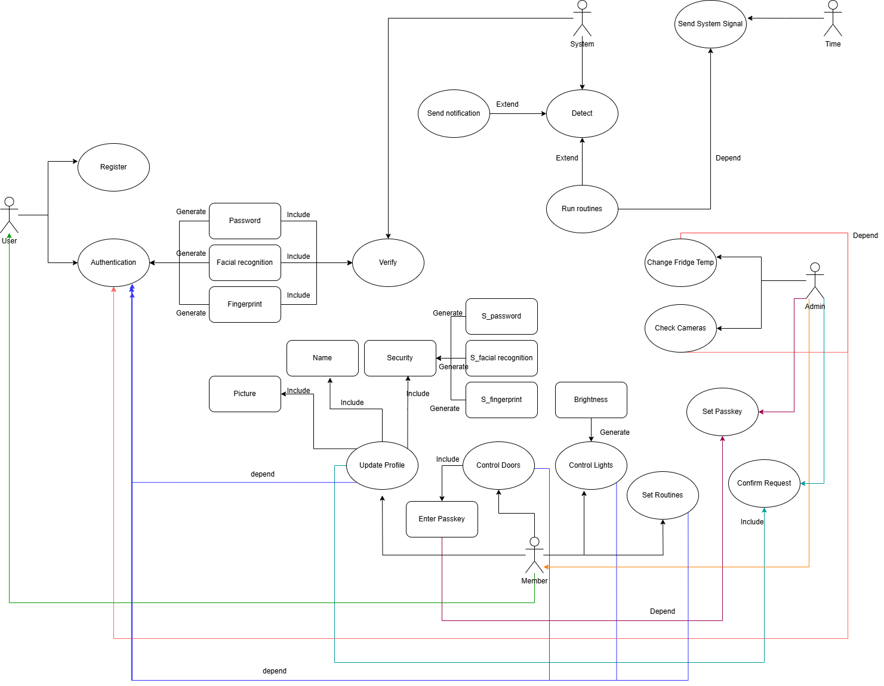

Use-Case Name: | Check Cameras
Use-Case ID: | SHA – 007
Priority: | HIGH
Primary Actor: | Admin
Description: | This use case describes the event the Admin is checking the security cameras on his mobile phone or a website.
Precondition: | The user should be authenticated as an Admin to use this use case.
Typical Course of Events: | Actor Action | System Response
 | 1. The user clicks on the “Check Cameras” button.  4. The admin can see what the cameras are recording, the member clicks on a camera for focus.  6. The admin can see the desired camera in full screen. | 2. The System verify the connection between the cameras and the admin.  3. The System grants access to the cameras.  5. The System opens up the camera, the latency is reduced with other cameras to allow for better streaming.
Conclusion: | The use case concludes that the admin has seen the security cameras.
Post-Condition: | After the connectivity is checked for establishment. If there’s a stable connection, the admin can see the cameras.  The System should inform the user of a possible reason for the lack of connectivity, and also contact other members about the problem.

Use-Case Name: | Set Routines
Use-Case ID: | SHA - 008
Priority: | HIGH
Primary Actor: | Admin
Description: | This use case describes the event the Admin is setting up routines on his mobile phone or a website.
Precondition: | The user should be authenticated as an Admin to use this use case.
Typical Course of Events: | Actor Action | System Response
 | 1. The user clicks on the “Set Routines” button.  3. The admin chooses what devices to automate and a time factor or set of events to trigger the routine.  7. The admin sees the validation message. | 2. The System grants access to the “Set Routines” interface.  4. The System checks if the Routine is a valid Routine.  5. Once the routine is verified to be valid, it gets saved to be used later by the admin.  6. The System returns a message for the admin to know his routine has been saved and is running correctly.
Conclusion: | The use case concludes that the admin has set a routine and it was added to the saved routines.
Post-Condition | If the routine is valid, the admin will be informed. The system should inform the Admin in case there’s any errors happening or if the routine is impossible to be made.

Use-Case Name: | Door Locks
Use-Case ID: | SHA – 005
Priority: | HIGH
Primary Actor: | Members
Description: | This use case describes the event that members are locking or unlocked doors in the house.
Precondition: | The user should be authenticated as a member or an admin to use this use case.
Typical Course of Events: | Actor Action | System Response
 | 1. The user clicks on the “Door Locks” button.  3. A member clicks on the desired door to unlock.  5. Member enters the pin number  8. The member is able to open the door. | 2. The System grants access to the “Door Locks” interface.  4. The System asks for a pin.  6. The System verifies the pin number  7. Access is granted and the door is unlocked.
Conclusion: | The use case concludes that the door was unlocked.
Post-Condition | If the user is authenticated as member and the permission to unlock the door is granted, the member is able to open the door.  The system should inform the Admin in case the member is trying to unlock without permission.

DFD Level 0:

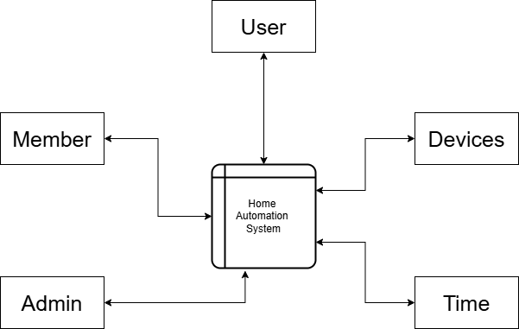
DFD Level 1:
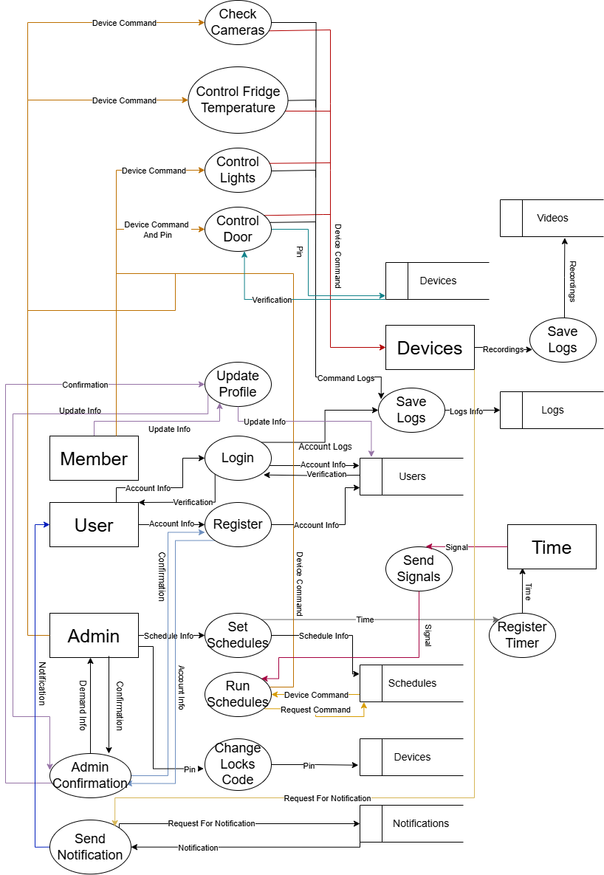
ERD:

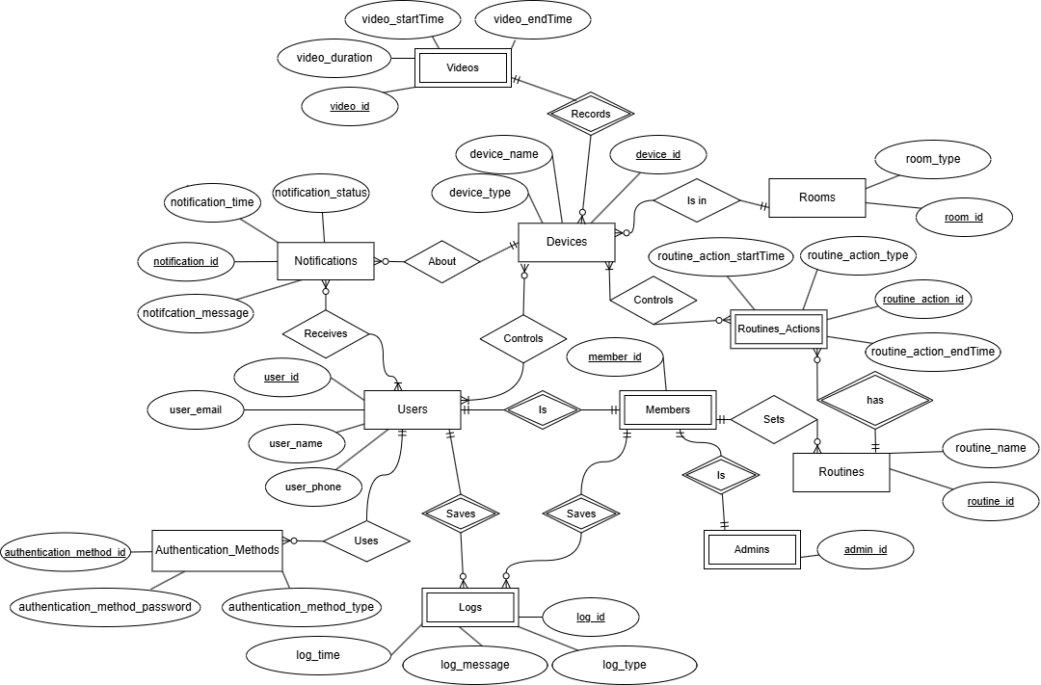

GUI: LOGIN & MAIN INTERFACE:
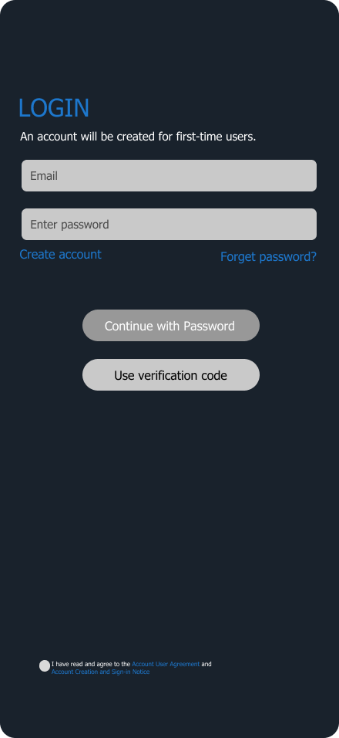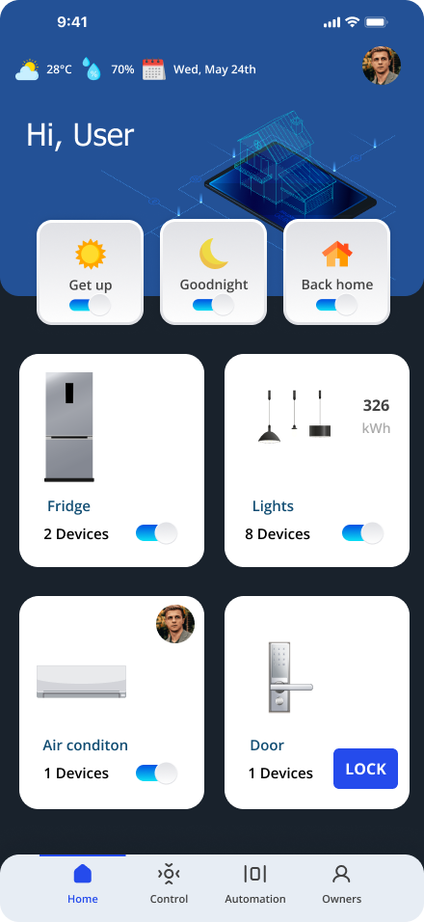
GUI: REMOTE CONTROL:
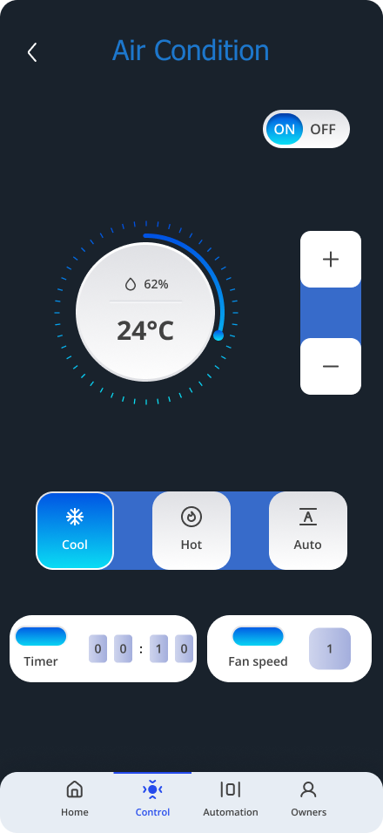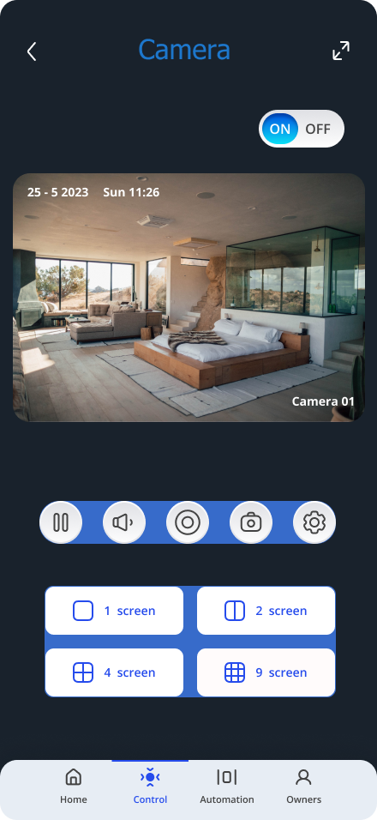
GUI: REMOTE CONTROL:
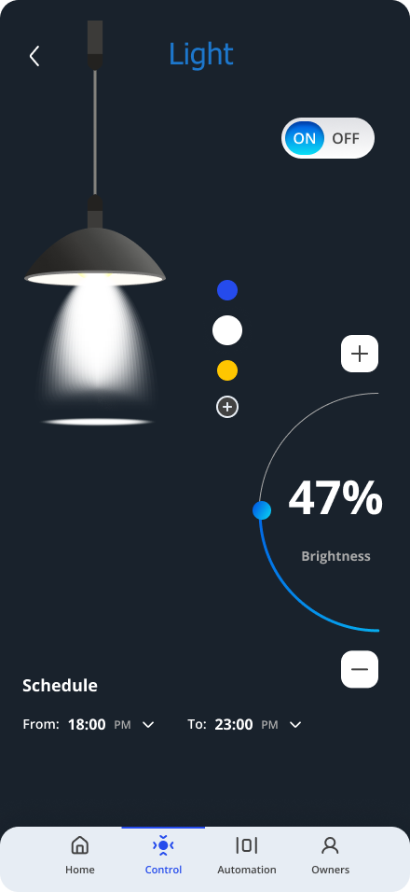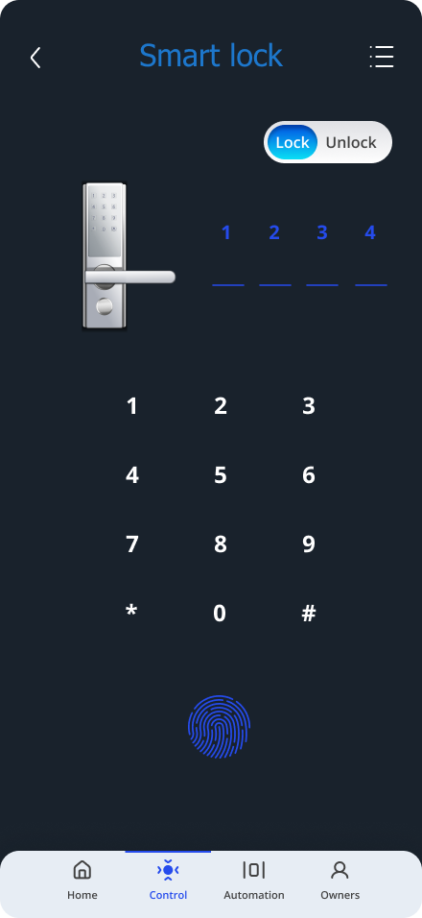

GUI: AUTOMATION:
